
EMMANUEL CHRISTIAN SCHOOL
“walk as children of light”

“A thriving Bible-based learning community”

Teacher Aide Position – February 2026

Thank you for your interest in the Teacher Aide Position we currently have available.

This is fixed term position until the end of the 2026 school year. Hours will be between 14-17 hours per week to be negotiated with the successful applicant during term time. The current need is for Tuesday and Wednesday mornings and all day on Thursdays and Fridays.

The key tasks will include a combination of:

- Supporting students with identified needs (under the direction of the class teacher)
- Supporting class teachers in meeting the needs of students within our Year 1-6 Primary School
- Providing extra supervision during the morning tea break in the playground. (If this is required an alternative morning tea break will be provided for the teacher aide)

If you would like to apply for this position, then please complete the application questions which follow. The start date would be as soon as possible.

As this position involves working in the School environment a clear Police check will be a condition of appointment.

If you have any questions, then please feel free to make contact either by email or phone

Phone: 359 3593
Email: vacancy@emmanuelchristian.school.nz

Regards

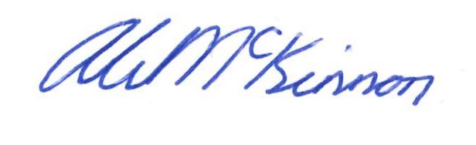

Alistair

Alistair McKinnon
Principal

Application for Appointment
Teacher Aide

- Applicant Details

Full Name:

Address:

Postal Address (if different from above)

Email Address

Contact Telephone numbers | Home  ( ) | Other (if appropriate)
Contact Telephone numbers | Mobile

Please provide details of previous experiences that you have that relate to this task. These could be previous employment, education or other experiences:

Please indicate why you would like to work as a Teacher Aide at Emmanuel Christian School, and what strengths you could offer to this task.

As a Christian School it is important that all staff are willing and comfortable to uphold the Christian character of the school. We have a daily lived expression of Christian faith in action. Please indicate any personal church involvement and your willingness to support this part of school life.

Please provide details of 3 referees which we could contact. (These could be professional or character referees)

Name:

Position:

Phone Number:

Name:

Position:

Phone Number:

Name:

Position:

Phone Number:

Authority to approach referees:
I authorize the Board of Trustees, or nominated representative, to approach or make enquiries to the referees named above to assure the board of my suitability for the position at Emmanuel Christian School. Yes / No

Medical Conditions:
Do you have any medical or physical disabilities/needs that would prevent or hinder you carrying out all of the duties of the position described?

If Yes please provide details.

Residency

- Are you a NZ Citizen?

- If not do you have a residence status or work permit to allow you to work in NZ? (please provide detail)

All employees working on a school site require a police check on a regular basis and before they start work.
The Board reserves the right to investigate or seek clarification on any aspect of an application for short listed applicants. Do you have any criminal convictions (apart from MINOR traffic infringements) either discharged or pending that the school should be aware of? |  | Yes / No
If Yes please provide details

Identity Check
All employees of the Board must prove their identity. This process will be completed for the successful applicant prior to commencing.

I Certify that:
The information I have supplied in this application is true and correct. I understand that if any false or misleading information is given in this application or my curriculum vitae, or any material information is suppressed, I may not be employed, or if I am employed, my employment may be terminated immediately. I understand that a suitably clear NZ police check will be required as a condition of employment.
Applicants Signature: Date:
(All this information will remain confidential to the Board of Trustees and those involved in the selection procedures)
By signing this application you give your consent for the Emmanuel Christian School Appointment Committee to seek further clarification and/or information about you from other relevant people. This includes verification of all information provided in support of this application.

